**FYP SRS Document**

Final Year Project

Software Requirement Specification

For

**Trafficviz**

(BSCS Fall 2017-2021)

By

128

|  |  |  |  |  |
| --- | --- | --- | --- | --- |
| S# | **Name** | **Registration #/Roll #/Section** | **Mobile #** | **Project ID** |
| 1. | Muhammad Umar Farooq | Fa-2017/BSCS/317 - G | 0301-5339926 |  |
| 2. | Muhammad Usama Javed | Fa-2017/BSCS/323 - G | 0306-4718518 |

**Supervised by:**

Ma’am Sowaiba Khan **___________________ (**Signature**)**



Department of Computer Science

Lahore Garrison University

Lahore

Table of Contents

Introduction 1

**Purpose:** 1

**Document Convention:** 1

**Intended Audience and Reading Suggestions:** 1

**Project Scope:** 2

Overall Description 2

**Product Perspective:** 2

**Product Functions:** 2

**User Classes and Characteristics:** 2

**Operating Environment:** 2

Software used: 2

Hardware Tools: 2

**Design and Implementation Constraints** 3

Accident Detection Circuit & Modular Diagram: 3

Traffic Signal Circuit & Modular Diagram: 4

**User Documentation** 4

External Interface Requirements 4

**User Interfaces:** 4

**Software Interface:** 5

Arduino IDE 5

**Hardware Interface:** 5

Wi-Fi – Wireless Fidelity 5

GPS - Global Positioning System 5

IR Module 5

LED: 5

**Communications Interfaces** 6

System Feature 6

**Functional requirements** 7

Accident detection requirement 7

Traffic Control requirements 8

Ambulance detection 8

Other non-functional requirements 8

**Performance Requirements** 8

**Security Requirements** 8

**Software quality attributes** 8

Accessibility 8

Reliability & Availability 8

**Business Rules** 8

References 9

# Introduction

## **Purpose:**

Traffic management is a big issue now a days in our society because the growth of population and vehicle. We loss many lives due to emergency rescue vehicle such as fire brigade and ambulance get stuck in traffic jam or traffic signal and waste their time. Our aims to detect the police car and ambulance using sensors and turn on the green signal for police and ambulance route and another signal will goes red. In this system we give access to ambulance driver if ambulance is away from signal and there is no sensors to detect ambulance so he can use wireless system to communicate with traffic controller.

Rate of accident has risen due to more traffic. The main objective of traffic vision to detect the accident and inform the traffic controller and rescue team immediately through wireless communications technique. Email device will be used to send email in short time. When the accident occurs, the accelerometer and vibration sensors will be activated and send information to the rescue and police station. Through the GPS system we will find where the accident occurs. The accident can be detected by a vibration sensor and accelerometer which is used as major module in the system.

## **Document Convention:**

Following are the requisite of this SRS document

**Heading level 1**

The heading should be written in bold. The font size and style should be 18 and Time new roman.

**Heading level 2**

The heading should be written in bold. The font size and style should be 16 and Time new roman

**Heading level 2**

The heading should be written in bold. The font size and style should be 12 and Time new roman

**Para Style**

In paragraph writing the font size is 12 with 1.5 line spacing

**Margins**

1-inch from right side and 1.25 inches from left side

## **Intended Audience and Reading Suggestions:**

This project is a prototype for the ambulance & Accident detection.  It is restricted within the traffic controllers and hospital management. This project is useful for the traffic controllers and as well as to the vehicle’s driver.

## **Project Scope:**

The overall goal of our project is to device a system that will ultimately control the increasing traffic load along with reducing the risk of accidents. Our project is way better than the previous because a single device can help us to minimize the effect of several problems. Our single device can be used to detect the accidents and their reporting and control the traffic problems like over-speeding and flow of traffic.

# Overall Description

This part will explain our project in detail.

## **Product Perspective:**

Increasing load of motor vehicles on the roads results in higher accidents rates as well obstruction in the traffic flow. In this system, we aim to add 2 features.

## **Product Functions:**

* First feature is to detect the ambulance using sensors. An IR sensor is placed in traffic system to detect ambulance and change the signal light to green for ambulance route.
* Second feature is to detect the accident and inform the rescue team and traffic police immediately.

## **User Classes and Characteristics:**

* Medical Centers
* Traffic Police department
* Police Department
* Common people

## **Operating Environment:**

### Software used:

1. Operating System: Windows 10 or higher.
2. Front End: Implementation on hardware/simulation
3. Back End: Programming language such as C/C++

### Hardware Tools:

1. Microcontrollers (NodeMCU and Arduino Nano)
2. Wi-Fi Module (ESP8266)
3. GPS Module (NEO-6M)
4. Accelerometer Sensor (MPU-6050)
5. Vibration Sensor (SW420)
6. IR Module (Infrared Transmitter and Receiver)
7. Traffic signals
8. Motor vehicles
9. Ambulance
10. LEDs
11. Voltage regulator
12. Push Button
13. Batteries
14. Toggle Switch

## **Design and Implementation Constraints**

1. C/C++
2. Proteus

### Accident Detection Circuit & Modular Diagram:

### Traffic Signal Circuit & Modular Diagram:

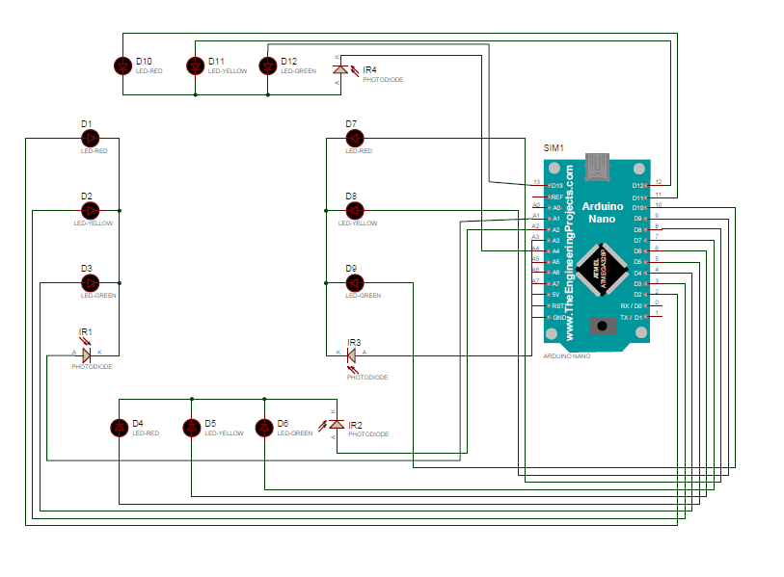

## **User Documentation**

* Datasheets
* User guide
* Blogs
* Tutorials
* YouTube channel

# External Interface Requirements

## **User Interfaces:**

## **Software Interface:**

### Arduino IDE

Arduino IDE is an Integrated Development Environment for programming on Arduino Boards, which makes it easy to write code and upload code to the board. The environment is written in Java and is based on Processing and other open-source software.

## **Hardware Interface:**

### Wi-Fi – Wireless Fidelity

Wi-Fi is used as a media which is used to control and communication within short range. When it’s connected with internet then data transfer ability and communication area has become wide over the world. It has its own deterministic character. Hence no need to waste time by manual operation and transportation. Hence it is considered as highly efficient communication through the mobile, laptop and IoT devices which will be useful in industrial controls, automobiles, home, and appliances which would be controlled from anywhere else. It is also highly economic and less expensive; hence Wi-Fi is preferred most for this mode of controlling and communication. Hence this automatic system is more efficient and less expensive and more convenient to use from were ever possible. Hence can be preferred mode of communication for controlling purpose.

### GPS - Global Positioning System

GPS is used in vehicles for both tracking and navigation. Tracking systems enable a base station to keep track of the vehicles without the intervention of the driver where, as navigation system helps the driver to reach the destination. When an accident occurred in any place then GPS system tracks the position of the vehicle and sends the information to the particular person through Email by alerting the person. GPS module sends the data related to tracking position in real time, and it sends so many data in NMEA format. NMEA format consists several sentences.in which we only need one sentence. This sentence starts from $GPGGA and contains the coordinates, time and other useful information. This GPGGA is referred to GLOBAL POSITIONING SYSTEM FIX DATA.

### IR Module

The IR sensor module consists mainly of the IR Transmitter and Receiver, Op-amp, Variable Resistor (Trimmer pot), output LED in brief. This module has two IR led, one is receiver and other is transmitter. IR Transmitter LED emits light, in the range of Infrared frequency. IR light is invisible to us as its wavelength (700nm – 1mm) is much higher than the visible light range. IR receiver as its conducts when infrared light falls on it. It is a semiconductor which has a P-N junction, operated in Reverse Bias, means it start conducting the current in reverse direction when Light falls on it, and the amount of current flow is proportional to the amount of Light. This property makes it useful for IR detection. It looks like a LED, with a black color coating on its outer side, Black color absorbs the highest amount of light.

### LED:

LED means "light emitting diode." A diode is an electrical part with two terminals which lead the power just one way. With an electrical flow, the diode radiates a brilliant light around the little bulb. It is a p–n intersection diode that radiates light when enacted. At the point when a reasonable voltage is applied to the leads, electrons can recombine with electron openings inside the gadget, discharging vitality as photons

## **Communications Interfaces**

Wi-Fi Module is used to communicate with the mobile device or computing machine for accident detection. For Hologram and ambulance detection we use internet/cloud to communicate in this project.

# System Feature

This part will illustrate the features of our model in detail with their intendent uses and accompanied risks

|  |  |  |  |
| --- | --- | --- | --- |
| **Sr #** | **System Feature** | **Description** | **Priority** |
| 1 | **Accident detection by Wi-Fi Module** | Traffic vision to detect the accident and inform the traffic controller and rescue team immediately through wireless communications technique. Wi-Fi module will be used to send email in short time. When the accident occurs, the accelerometer and vibration sensor will be activated and send information to the rescue and traffic teams. Through the GPS system we will find where the accident occurs. The accident can be detected by accelerometer and vibration sensor which is used as major modules in the system | High |
| **Stimulus Sequence and Response** | | | |
|  | | | |
| 2 | **Ambulance detection** | To detect the ambulance using IR Sensor and turn on the green signal for ambulance route and another signal will goes red. In this system we give access to ambulance driver if ambulance is away from signal and there’s no sensor to detect ambulance so he can use wireless system to communicate with traffic controller | High |
| **Stimulus Sequence and Response** | | | |
|  | | | |

**TECHNOLOGY** **PRICE**

NodeMCU With Wi-Fi

Arduino Nano

GPS Module 8,500 Rs

Accelerometer Module

Vibration Sensor

Traffic Signal (4) 700 per piece

Motor vehicle (2) 700 Per vehicle

Ambulance 700

IR Sensors (4) 800 per sensor

Voltage Regulator 8000

LEDs (15) 800

Batteries (4) 5000

PCB Vero Board

Total 75,000 to 80,000

## **Functional requirements**

### Accident detection requirement

1. Accelerometer modules need to detect accident. When x or/and y axis change the position such as x => 5 ms^2 or/and x =< -5 ms^2 or/and y => 5 ms^2 or/and y =< -5 ms^2 then sensors give signal to controller.
2. Vibration sensors need to detect accident. When sensor detect vibes or vibration pulses greater than 10000 2 then sensors give signal to controller.

### Traffic Control requirements

1. Traffic signals are changing signal lights according to time pattern. When a signal at green then all other signal goes to red at same chowk. When signal turn green to red then other signal goes to green. So whole signals working wise versa.

### Ambulance detection

1. Traffic signal works normally when a ambulance come to near at signal then sensor detect the ambulance and turn the signal into green and other all signals of same chowk goes to red
2. When ambulance goes then traffic signal work normally.

# Other non-functional requirements

## **Performance Requirements**

1. The product shall be based on wireless communication.
2. The product shall take initial load time depending on internet connection strength which also depends on the media from which the product is run.
3. The performance shall depend upon hardware components of the client/customer.

## **Security Requirements**

1. Data Transfer: The system shall use secure sockets in all transactions that include any confidential customer information.
2. The system shall not automatically email when no accident occurs.
3. The system shall confirm all transactions with the customers.

## **Software quality attributes**

### Accessibility

1. The system shall provide Email Access.
2. The system may be providing Mobile Apps support.

### Reliability & Availability

1. This system available all the time when internet connected to this system.
2. This system easy to use.

## **Business Rules**

1. Hardware Configured for system shall display all the products which can be configured. The system shall allow user to select the product to configure. Provide comprehensive product details. The system shall display detailed information of the selected products.

# References

1. Ghuloum, H. *3D hologram technology in learning environment*. in *Informing Science & IT Education Conference*. 2010.
2. Gonzalez, R.C., R.E. Woods, and S.L. Eddins, *Digital image processing using MATLAB*. 2004: Pearson Education India.
3. Sonika, S., K. Sathiyasekar, and S. Jaishree, *Intelligent accident identification system using GPS, GSM modem.* International Journal of advanced research in computer and communication engineering, 2014. **3**(2).
4. Kumar, M.E., et al. *Vehicle theft identification and intimation using gsm & iot*. in *IOP Conf. Ser. Mater. Sci. Eng*. 2017.
5. Shiny, P., Banu, I. T., Thenmozhi, B., Sasikala, U. T., & Prabhu, M. R. Intelligent Traffic Control System for Congestion Control Using Image Processing, Ambulance Clearance, and Stolen Vehicle Detection. *International Journal of Advanced Research Trends in Engineering and Technology (IJARTET)*, *3*.
6. Prabhakar, M. K., & Kumar, M. S. (2013). GPS tracking system coupled with image processing in traffic signals to enhance life security. International Journal of Computer Science & Information Technology, 5(4), 131.
7. Kattukkaran, N., George, A., & Haridas, T. M. (2017, January). Intelligent accident detection and alert system for emergency medical assistance. In 2017 International Conference on Computer Communication and Informatics (ICCCI) (pp. 1-6). IEEE.
8. Chaturvedi, N., & Srivastava, P. (2018). Automatic vehicle accident detection and messaging system using GSM and GPS modem. *Int. Res. J. Eng. Technol.(IRJET)*, *5*(3), 252-254.
9. Gobhinath, S., Aparna, V., & Azhagunacchiya, R. (2017, January). An automatic driver drowsiness alert system by using GSM. In *2017 11th International Conference on Intelligent Systems and Control (ISCO)* (pp. 125-128). IEEE.
10. Amin, M. S., Jalil, J., & Reaz, M. B. I. (2012, May). Accident detection and reporting system using GPS, GPRS and GSM technology. In *2012 International Conference on Informatics, Electronics & Vision (ICIEV)* (pp. 640-643). IEEE.
11. Shimobaba, T., et al. *Proposal of zoomable holographic projection method without zoom lens*. in *Proceedings of the International Display Workshops*. 2011.
12. Robin Johny, K. and E. Poorvika, *Holographic Infra Red Air Traffic Control.* WORLD. **3**: p. 2D.